- Account and User Management
CD 01: Create a Personal Checking Account
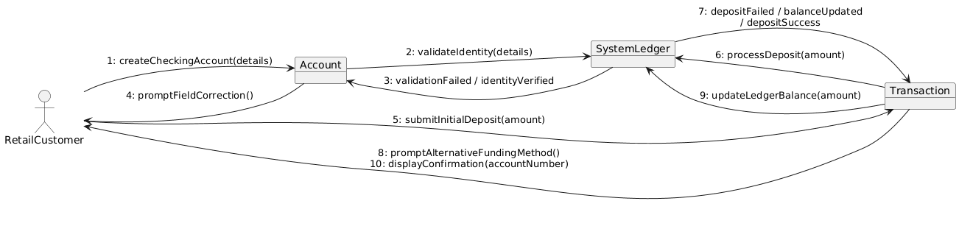
CD 02: Initiate Bulk Payroll Processing
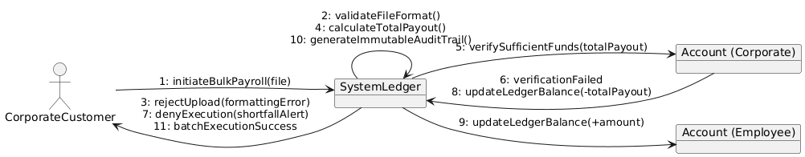
CD 03: Manage Multiple Authorized Signers
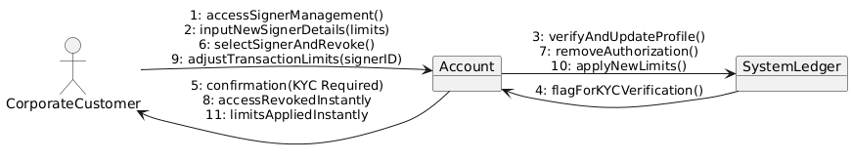
CD 04: Update KYC Documents
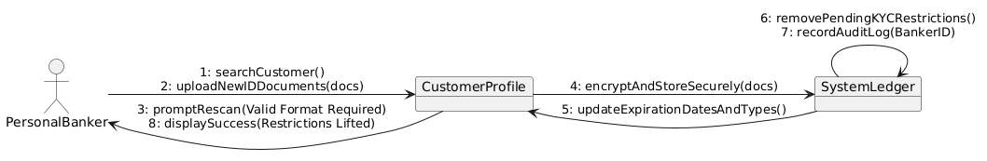
CD 05: Manage User Accounts (HR)
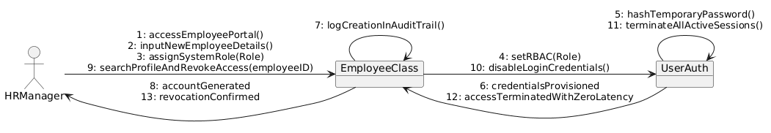

- Transactions and Cash Operations
CD 06: Process Cash Transactions
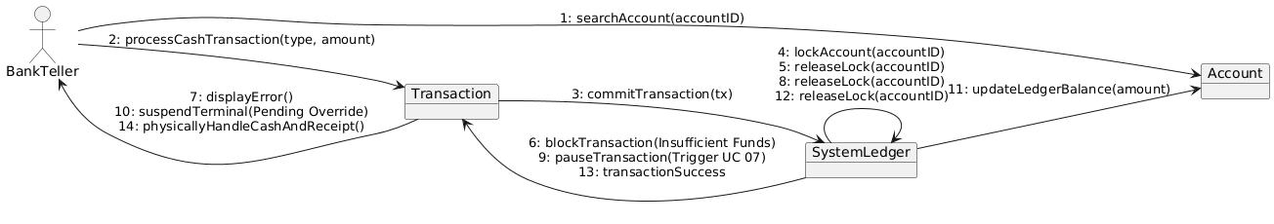
CD 07: Authorize Transaction Overrides
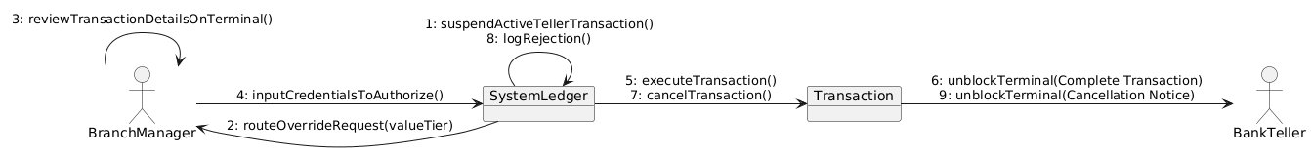
CD 08: Manage Branch Cash and Vault Operations
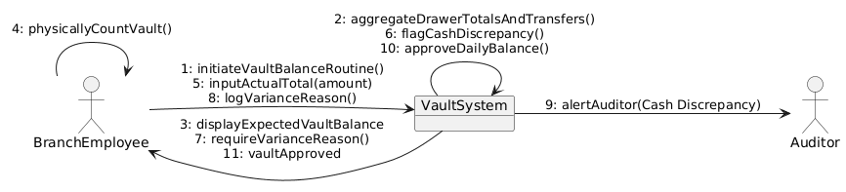
CD 09: Settle External Transfers
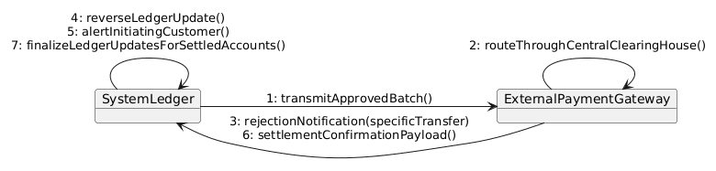
- Credit & Loan Processing
CD 10: Evaluate Loan Applications
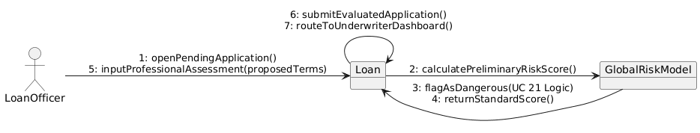
CD 11: Underwrite and Bind Loan Agreement 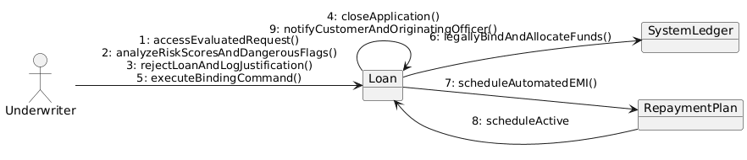
CD 12: Manage Defaulted Accounts and Asset Recovery
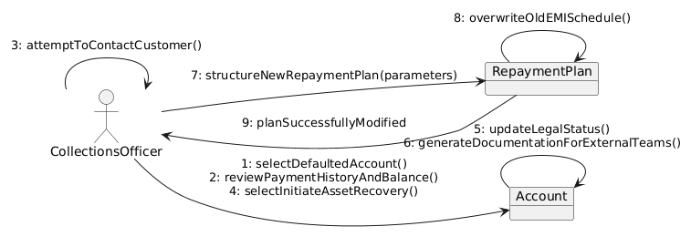

- Monitoring, Security and Admin
CD 13: Monitor Transactions and Generate AML Reports
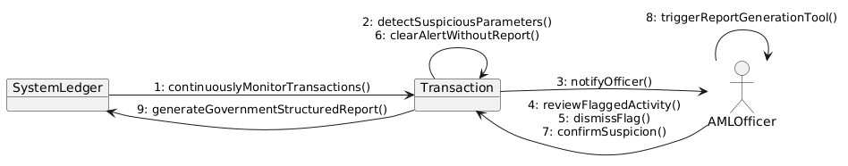
CD 14: View Action History and Audit Logs
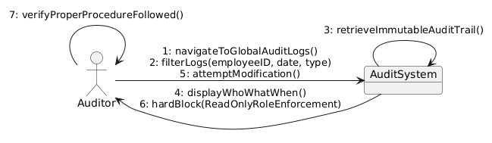
CD 15: View Profitability and Transaction Summaries
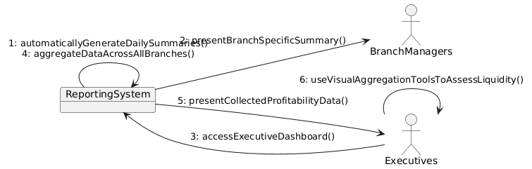
CD 16: Manage Core System Configurations and Backups
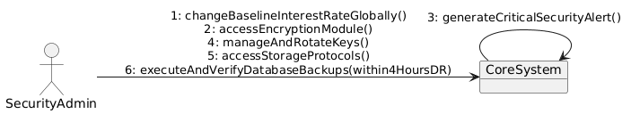

- Remaining Core Operations & System Actors
CD 17: Generate Account Statements
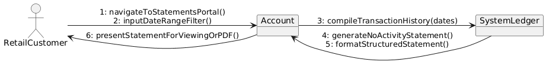
CD 18: Issue New Debit Card
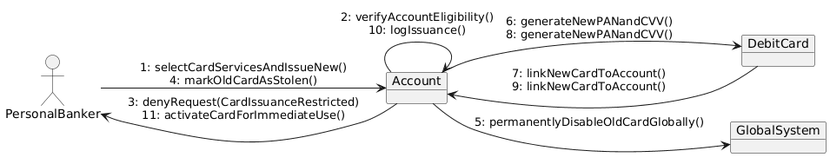
CD 19: Authenticate User
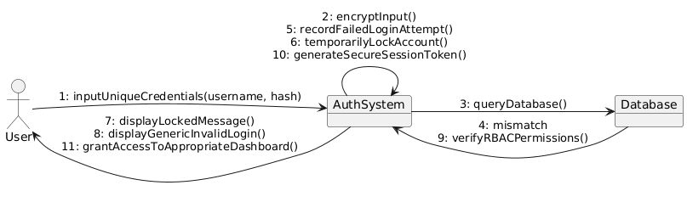
CD 20: Set Global Risk Parameters
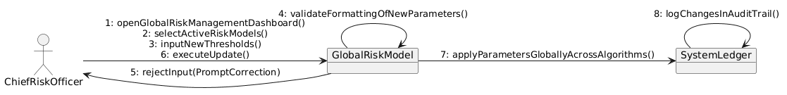
CD 21: Flag Dangerous Loans (System Actor)
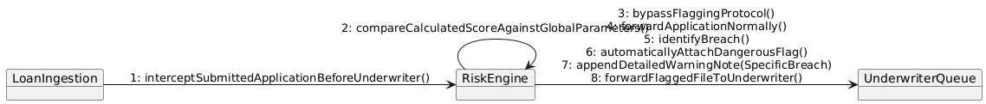

CD 22: Route Loan Requests (System Actor)
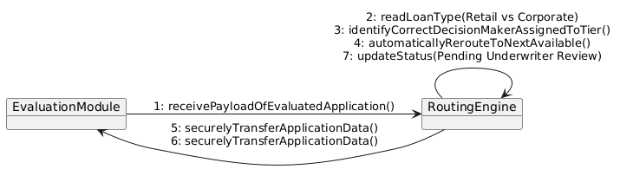
CD 23: Update Ledger Balances in Real-Time (System Actor)
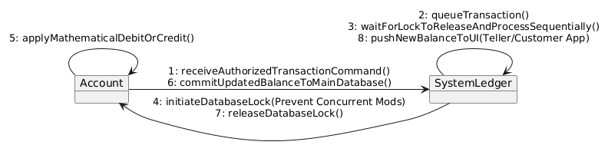
CD 24: Generate Daily Transaction Summaries (System Actor)
